**Python App on Nginx**

In this documentation, I will create one python application using the flask framework and set it up on the Gunicorn application server and launch the application and configure the Nginx web server.

**Step 1: Install python pip3 for python virtual environment and other packages.**

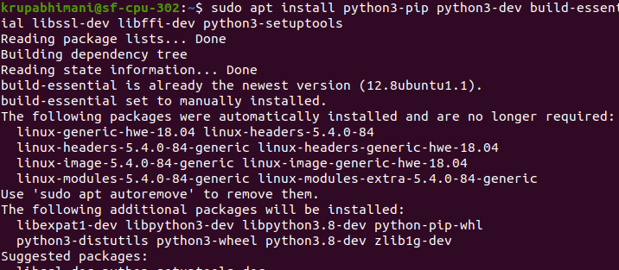

**Step 2: Creating python Virtual environment**

What is a python virtual environment?

* It is useful when you are working on different python projects that use different versions of the same packages. So in that case a virtual environment can be useful to maintain dependencies for both projects individually. It will create two different environments and keep dependencies of each project in scope of the particular environment.

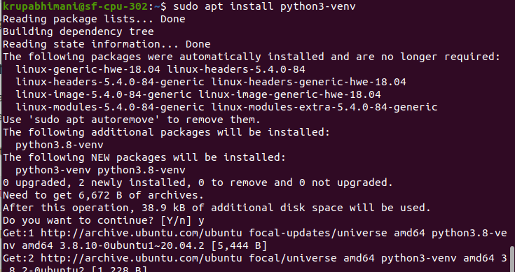

Now create one directory and move in directory and in that directory create one virtual environment to store python project requirements.

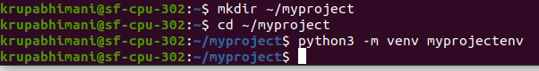

Activate the environment



**Step 3: Setting up the Flask Application**

Here, we will install flask and gunicorn and we will create one simple app.

Flask: it is a web framework of python which is used to build web applications in python.

Gunicorn: it is a pure python HTTP server WSGI application.

WSGI: It is a web server gateway interface.It is used to forward requests from a web server (such as Apache or NGINX) to a backend Python web application or framework.

Install wheel

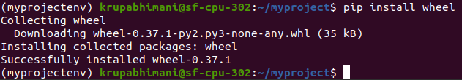

Install Gunicorn and flask

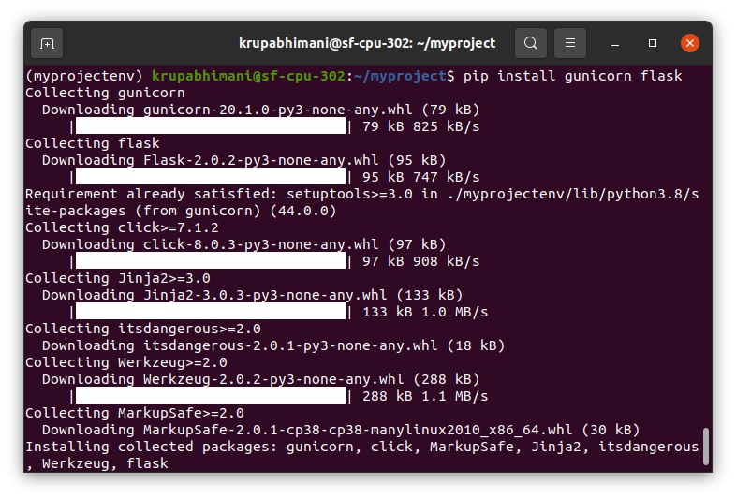

Create a sample web application using flask.

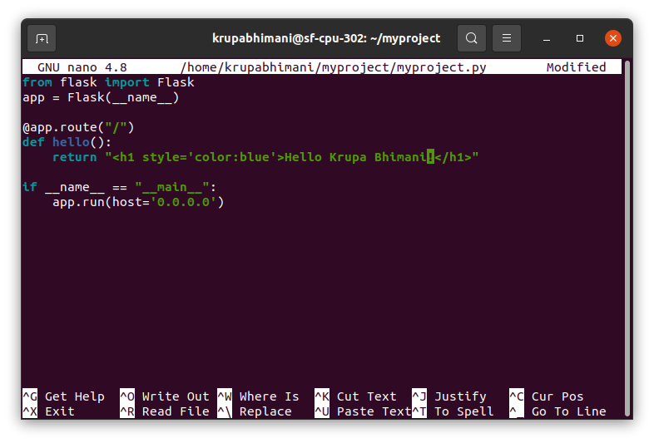

Allow access port to 5000.



Test your application

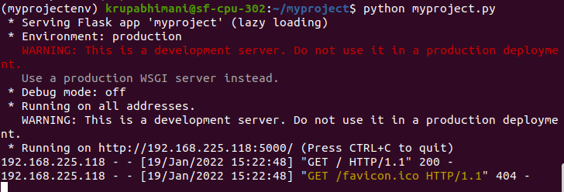

We can see it is running on 5000 port.

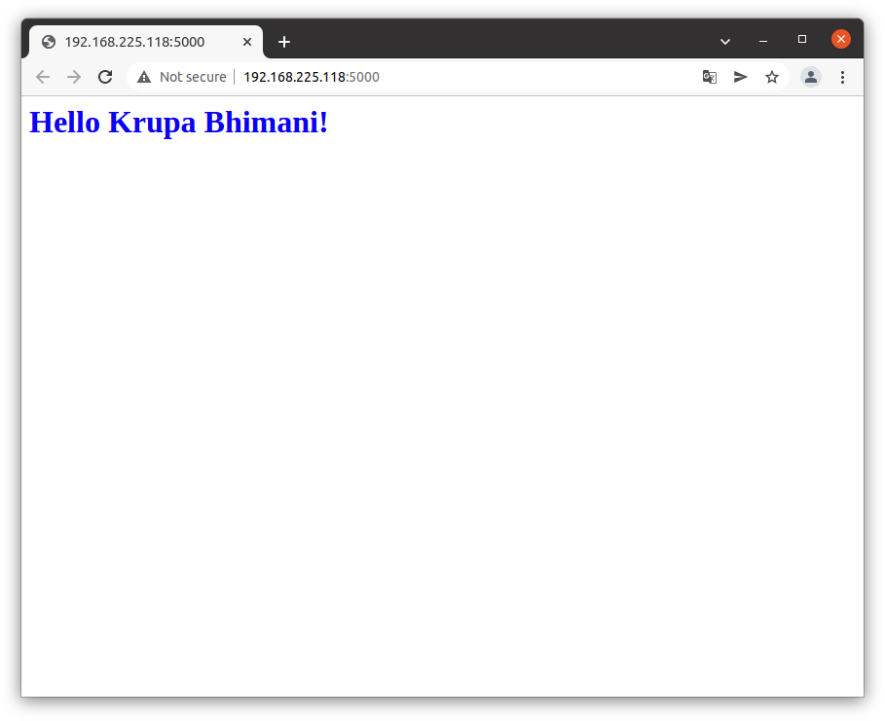

Creating the WSGI Entry Point

Create one file that will serve as an entry point for the application.

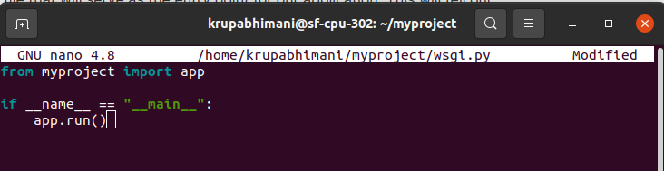

**Step 4: Configuring Gunicorn**

Pass the name of entry point

Also specify the interface and port to bind so that the application can start on a publicly available interface.

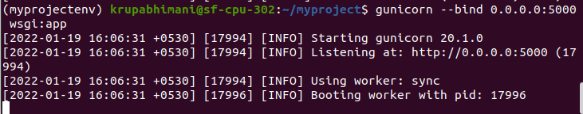

You can see it is running using Gunicorn server

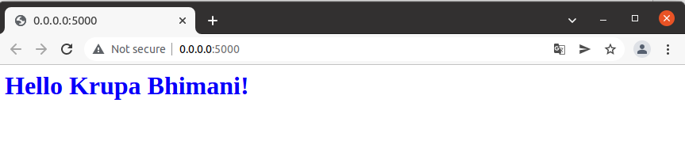

Create the systemd service unit file for automatically starting Gunicorn and server flask web application whenever server reboots.

[unit] : this section is used to specify metadata and dependencies.

[Service] : this section will specify the user and group that we want to run under.

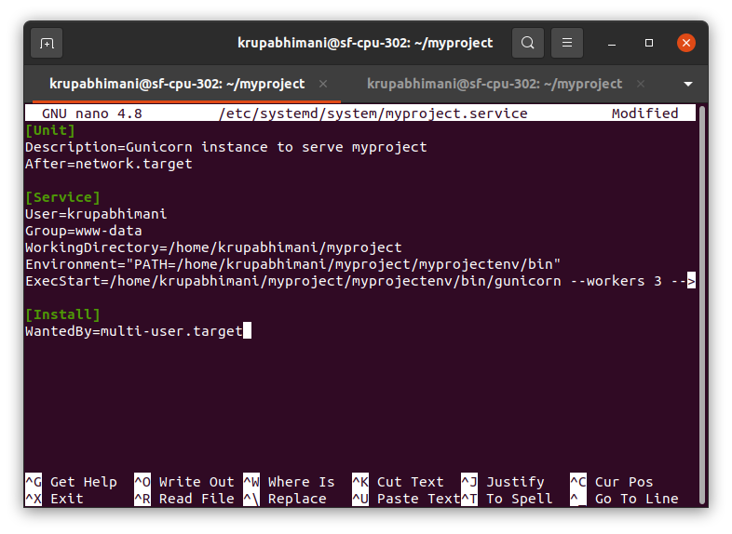

Start and enable the service

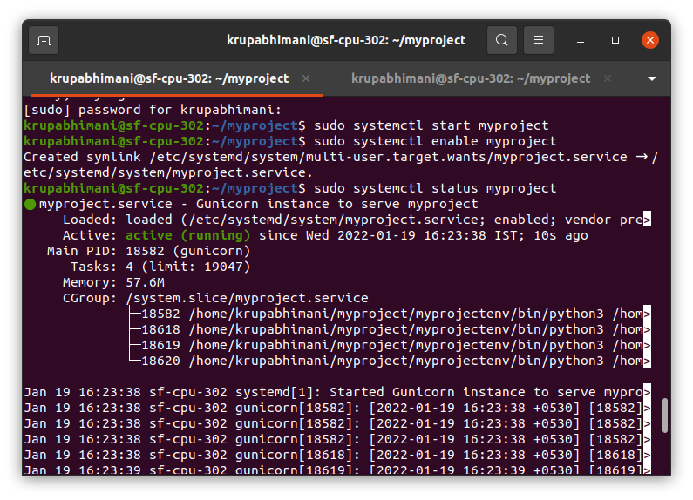

**Step 5: Configure Nginx to proxy request**

Make a file in sites available folder and pass the proxy

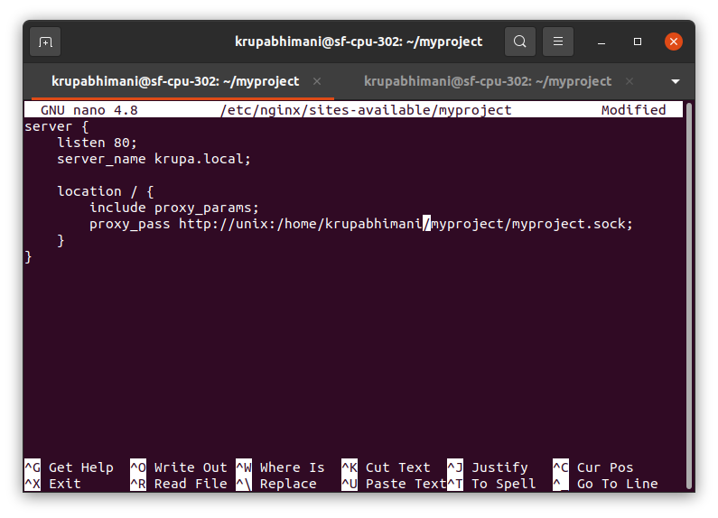

Create a soft link



Edit host file and add host in that file for your domain

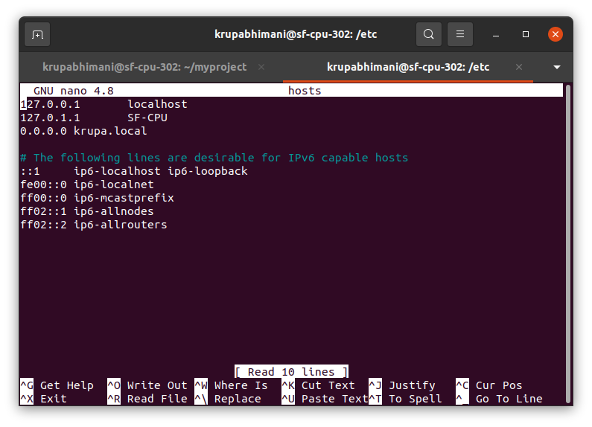

Check the syntax in nginx

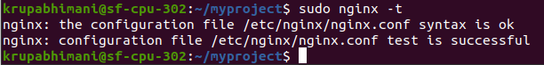

Give full access to the nginx

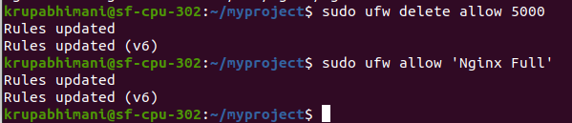

Restart the nginx and type krupa.local in the browser it will serve your python application.

